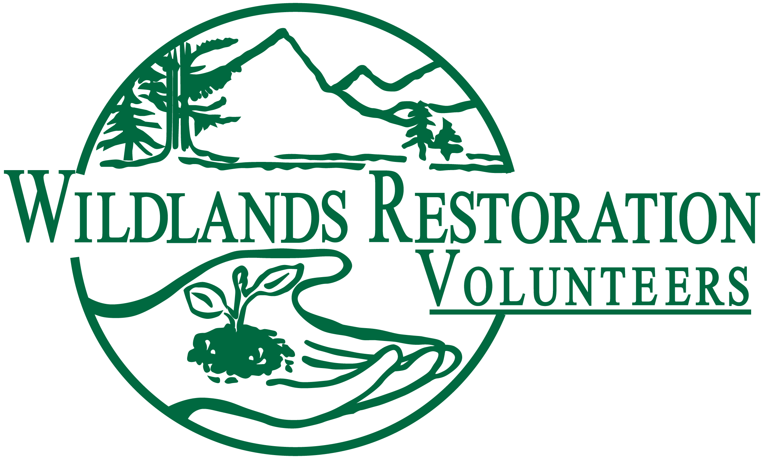
Project Leader
New Collective Wisdom for 2011

Purpose: This document summarizes new insights about how all WRV Project Leader’s can be most effective. This info is distilled from the annual WRV adaptive management process, and is disseminated annually to all WRV Project Leader’s (old and new). See the updated Project Leader Resources online or contact WRV for a CD for more information.

New Procedures or Resources all Project Leaders Should Know About:

1. PL Resources Online: All Project Leader Resources are now posted online. We will make every effort to make sure these documents are up to date and that all resources are posted, but if you see something that is missing or needs an update please let us know. The website for Project Leader Resources is http://wlrv.org/community/leader-resources.html. From here click on Project Leader Resources.

2. PL Check List Makes Organization Easier: A new document and very powerful document in titled the PL Check List was developed in 2010. The PL Check List is an extensive template that breaks project planning down into seven major categories and even further into tasks under each category. Each task can be tracked by status, owner, recipients/attendees, when/where, and also has notes on that specific task from previous years lessons learned. This tool has been integrated into PL training, so all new PL’s will be familiar with it. This is a great resource for newly graduated PLs as well as seasoned veterans.

3. Q: How deep should I plant the willows?
A: Ask the TA:
After a careful analysis of all the 2010 surveys and project debriefs, one major take away was that project team member roles and responsibilities are not always well defined or followed. There has always been a lot of flexibility on what each role will do based on a specific project, however we are getting feedback that it is important to define this early on and stick to it. Examples include volunteers and crew leaders getting technical advice from a role other than the Technical advisor, what exactly the role of the Assistant Project Leader will be, who makes the final technical calls the agency or WRV. Then on project day it is not the PL’s responsibility to know everything, you just need to know who does know the answer.

4. Lets get formal with our APLs: It has always been hard to define what Assistant Project Leaders should do so that they get the most form their experience as a trainee. There is no specific set of things that once done define someone as able to PL, however there are a set of core competencies that should be tested before an APL can drop the “A” and become a PL. Much like out crew leader mentoring program, we have added a short one page evaluation. This evaluation covers the six core competencies that we think are important for APLs to be exposed to. The idea is that the PL and APL will sit down at the beginning of the project and look at this sheet to see what the APL can do to get experience in each of the categories. At the end of the project they will sit down again and write out how the APL did. This evaluation will then stay with the APL as the work on different projects until they are comfortable with all the competencies. In no way is this document meant to be a scored evaluation or a test, its goal is to facilitate a more formal mentoring process.

Continuous Ways that PL’s can Improve:

5. Just a reminder that in 2009 WRV implemented the Safety Net. A series of three documents intended to help avoid, prepare for and record any accidents on projects. These include the Risk Assessment Form, the Emergency Response Plan, and the Incident Report. These documents and a description of when and how to use them are posted online.

