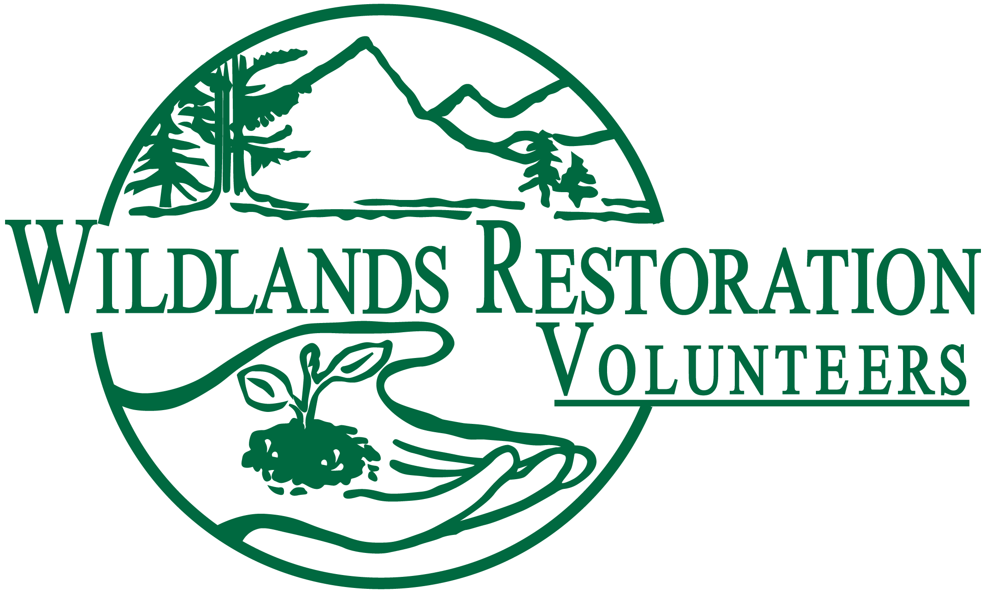
Project Leader Collective Wisdom

The most important factors to success in a project (and fun/satisfaction in the planning team) are:

- Clear early communication
- Respect
- Flexibility

Procedures & Resources All Project Leaders Should Know About

- WSL makes the first call
At the leader summit it was decided the WSL will contact the PL to get the collaborative project planning started. Ideally contact will be 8 weeks prior to project date but the timing will vary depending on complexity of the project. As a PL, feel free to call the WRV office and check in with the WSL earlier.

- Clarify the ambiguity of roles and responsibilities
No two people are alike and no two projects are either. As a community we like leaving flexibility and even little overlap in roles to allow each project team to fit their own mold. This kind of flexibility allows the team to help each other out and play to each team member’s strength. However we do need to make sure that we are not letting parts of the project fall through the cracks. To allow flexibility and still run a successful project, the PL and WSL need to sit down early in the planning process and define their roles. The PL checklist is a great place to start. It has suggestions for who is responsible for the major tasks associated with planning a project. Go through the list and verify that the person assigned to the task is willing and able to do the job. Also remember to verify with the rest of the project team members such as the TM, TA, LC.

- MOU (or something like it)
Historically, WRV used a lot more Memorandum of Understandings documents to define the scope of work. The Leader Summit taught us that while these are not required, we do need to get better about WRITING down a work plan or scope of work with the agency. In some cases the expected work outcomes are documented in contracts or grants. In other cased it can be in emails. The key is to get it in writing and get it as early as you can.

- Decide who is the primary with the Agency Contact
This one is simple. Talk with the WSL and determine if one or both of you will be communicating with the agency. We want to appear efficient and professional to our land management partners so it is critical that we are not overwhelming them with questions or asking the same questions. Often having one point of contact will make it easier for the project team and the agency.

- Handout previous documentation
With the help of the WSL get your hands on any previous documentation for projects at the same location, of the same size, working on the same technical aspect or with any other similarities. We want to prevent extra work and not reinvent the wheel. Reusing parts of the documents previous project teams prepared is a great way to save time!

- Early contact with the Project Team is key
Early, early, early. Getting in contact with your project team early and getting them involved will reduce the likely hood of team members dropping out and will also make the whole project planning easier for everyone. So send an email early on and hold a quick team meeting.

- Pass that torch EVERY time
The WSL and PL start the collaborative planning with a meeting called passing the torch. This should happen on every project. Having this meeting will facilitate nearly every other piece of wisdom in this document. It is the place to define roles, set up contact with the rest of the project team, talk about the MOU, transfer previous project documentation, get access to the data base, decide who will talk with the agency and much more.

- How many volunteers?
Part of orchestrating a great project is getting the number of volunteers right. Make sure your WSL and TA are involved so that there are enough hands to get the work done and pass the count on to the Lead Cook making sure to differentiate between total number of people signed up and actual expected number of people showing up after attrition.

- Read Tribal Wisdom!
The only way for us all to stay up-to-date is to revisit these tribal wisdom documents.

- The Project Leader Trainee
To do as much work as we do, we need as many Project Leaders as we can. Each year 20 or so trainees go through our training and then head off to be mentored by folks like you! It is easy to ask your PL trainee to do the Risk Assessment or a couple other small things but for them to really get the experience it will take some planning and work from you both. Sit down with your trainee and carve off as much of the project as they are willing. Push them to take on large complex pieces so that they grow their skills and are prepared to take on a project all on their own. In many cases it will take a lot of collaboration and work to carve of a significant piece of a project but it will be worth it when we have one more capable Project Leader in our community. To help you with this process there is a Project Leader Trainee Evaluation sheet that the two of you can look in the EARLY planning phases and decide what areas your trainees need more practice.

- H₂O
The Project Leader has ultimate responsibility for finding a water source and the Tool Manager is responsible for filling up the water jugs and brining them. The Lead Cook then takes over responsibility for water but may illicit help from other team members or crew members.

Other updates: PL resources – logistical worksheet add-ons:
- Camp kitchen location determination – instead of just Lead Cook (LC), replace with AC/LC/PL
- Alcohol to be served/who will serve, who will enforce (Biermeister) – WSL, PL make decision; Lead Cook should be informed of beer and be aware
- PL ensures that logistical needs of the Lead Cook are met (e.g., soliciting help from volunteers for digging gray water holes, setting up toilets, setting up canopies and tarps, carting water, etc.)
- PL should ensure that TM and LC have adequate personnel to unpack and unload at tool shed.
- PL Discuss and decide with WSL/LC&TM about heater rentals and other weather contingencies before the project date.

PL resources – Communications worksheet add-ons:
- Remind volunteers to place ALL smelly items in bear fence or tool truck at night. Including personal snacks – not to be kept in tents!

