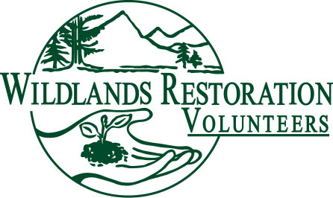
WRV Project Leader Role Description

Title: Project Leader

Team or Committee Affiliation: Project Team Member

Description: The Project Leader (PL) takes responsibility for project planning, oversight and execution. S/he leads and facilitates a team of skilled volunteer leaders to ensure successful project completion and an excellent volunteer experience.

Objectives:
The PL contributes vision and logistical management to the Project Team. S/he sees the “big picture” of project needs and, through effective communication, facilitation, coordination, delegation, and proactive planning ensures that the Project Team completes all steps necessary to plan, implement and document a successful project. The PL has a special interest in ensuring that the members of her/his team, and all volunteers attending the project, have a great volunteer experience.

Responsibilities:
- Serve as primary liaison between Project Team and WRV Staff Lead (WSL)
- Obtain and compile all project documentation from previous, or similar projects.
- Facilitate communication among Project Team members (Technical Advisor(s), Tool Manager(s), Crew Leaders, Cooks, etc.); schedule and facilitate planning meetings as needed; build team spirit
- Act as liaison with Agency Contact (AC) regarding project logistics, and coordinate with AC and TA to create a logistics plan and schedule
- Recruit additional team members as necessary, with support from WSL
- With Technical Advisor, determine number of volunteers needed to accomplish project and communicate WSL, who will oversee recruitment
- Prepare “Project Information” notes and any other communication for distribution to volunteers by WSL
- Coordinate educational talks, social gatherings, or other enrichment activities to be held on project day/weekend, as appropriate.
- Oversee project day logistics to ensure successful work and positive volunteer experience
- Document hours of all project team volunteers and record in WRV database
- Schedule and facilitate project debrief discussion, and provide project and completed documentation to WSL

Background or qualifications: PLs should have strong organizational, planning and communication skills. Experience planning some type of project or event required. Previous experience as a certified WRV crew leader and tool manager preferred.

Training/Preparation: Prospective PLs should attend several WRV projects before taking a leadership role, and will preferably have experience as a crew leader on a project similar to the one s/he is interested in leading. Ideally, PLs will complete the COTI/WRV Ecological Restoration Crew Leadership training and the WRV Project Leadership training prior to leading a project. WRV offers additional training opportunities in project management, group facilitation, and other topics.

Time / Place: PLs facilitate 1-3 Project Team meetings prior to the project; attend one or more site visits; participate in the Crew Leader Orientation, and conduct a debrief meeting after the project is complete. The PL arrives at the project site before volunteers and can expect to leave after all volunteers have departed.

Commitment: Lead, or mentor a new PL on, at least one project per year. May contribute to training and mentoring new PLs. May attend WRV organizational planning meetings.

Over-sight: PLs work with the Technical Advisor, WRV Staff, crew leaders, project support/cooks, tool manager(s), land management agency staff, and volunteers. The WSL and PL coordinate to oversee the project.

Measures of success: Clearly documented communication approach. Successfully completed work on project day; project volunteers welcomed, included and encouraged to participate in other projects, returning; project team members feel successful; “lessons learned” passed on to future project team. PL enjoyed themselves and want to be a PL again.

