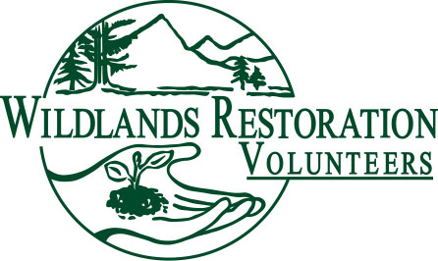
PROJECT MEDIC DESCRIPTION

Title:

Project Medic

Team or Committee Affiliation:

The Project Medic is a member of the project leadership team.

Description:

Medium to large scale projects have one or more designated Project Medics who are responsible for the safety of the project. Small projects should have one person with first aid training carrying a first aid kit.

Objective:

Ensure a medically trained presence on WRV projects.

Responsibilities:

Work with the Project Leader and Technical Advisor to determine what safety hazards are present in a project.
Provide a medical resource on a project.
Determine what other medical is available in the general area the project is located and list phone numbers and addresses where help can be requested.
Using a GPS identify possible helicopter medical evacuation sites on large projects.
Recruit trained volunteers.
Provide information on training that is available in the community.
Observe volunteers in regard to safety hazards in the environment, work habits, tool use and for signs of medical distress.
Contact proper authorities if additional help is required.
Mentor medical trainees.
Maintain first aid kit supplies.
Fill out the paperwork on reportable incidents.
Attend the project debriefing to provide feedback.

Background for Qualification:

Current certification in Red Cross First Aid and CPR training.
Current certification in Advanced Mountain First Aid.
Current AED training.
Prior experience working on WRV projects.
Medical training as EMT, MD, etc.

Equipment:

First aid kit, GPS, flashlight, telephone, Medic ID hat or vest, (overnight projects) tent identifier.

Training and Preparation:

Read the Safety Handbook.
Attend the preliminary project orientation and survey.
Work with an experienced mentor.

Commitment:

Project-by-project basis.

Over-sight:

Report to the Project Leader and other project staff. Turn in incident reports to the WRV Office or the Project Leader.

Measures of Success:

No safety incidents ideally. Using first aid training for treating small cuts, abrasions and strains. Obtaining advanced help in reportable incidents and a good outcome from
treatment administered or obtained.

