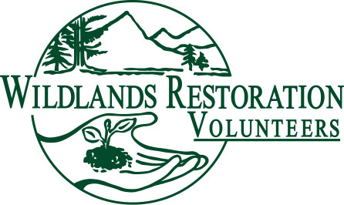
WRV Volunteer Role Description

Title: Technical Advisor

Team or Committee Affiliation: Project Team Member

Description: The Technical Advisor (TA) is a bridge between WRV and the land management agency for the technical aspects of the project.

Objectives: The TA translates the agency’s goals and creates a work plan for the project and effectively communicates the technical needs of the project to the crew leaders.

Responsibilities:
- The TA translates the scope of work into a project plan that includes: determining the number of volunteers, crew assignments, and a recommended tool list.
- The TA communicates the technical requirements of the project to the project team and crew leaders through a crew leader orientation and technical notes.
- The TA serves as the liaison between WRV and the land management agency.
- The TA coordinates the work on project day.
- The TA ensures the project is completed to the standards of the agency and WRV.

Background or qualifications: It is suggested that anyone desiring to be a TA should be a qualified crew leader. It is also helpful to have a background in resource management, habitat restoration, botany, erosion control, ecology, hydrology, landscape architecture or trail work but is not mandatory.

Training/Preparation: Anyone desiring to be a TA should attend projects of the type for which they want to be a TA, become an assistant TA and attend any TA training class that WRV offers.

Time / Place: A TA needs to attend an onsite orientation with the agency and any additional site visits prior to the project day (the number of visits depends on the complexity of the project). Coordinates and lead a crew leader orientation meeting prior to project day, write technical notes, attend all project team meetings and be at the project site 1 hour before the volunteers on project day.

Commitment: Technically lead at least one project per year.

Over-sight: The TA will lead the design effort, lead the crew leaders, work with the WRV project team and the land management agency. The TA will also evaluate the effectiveness of the design plan after the project.

Measures of success: The completion of a high quality project that meets the mission of WRV, well written, concise and usable technical notes, good technical design, good communication, and happy, satisfied volunteers.

